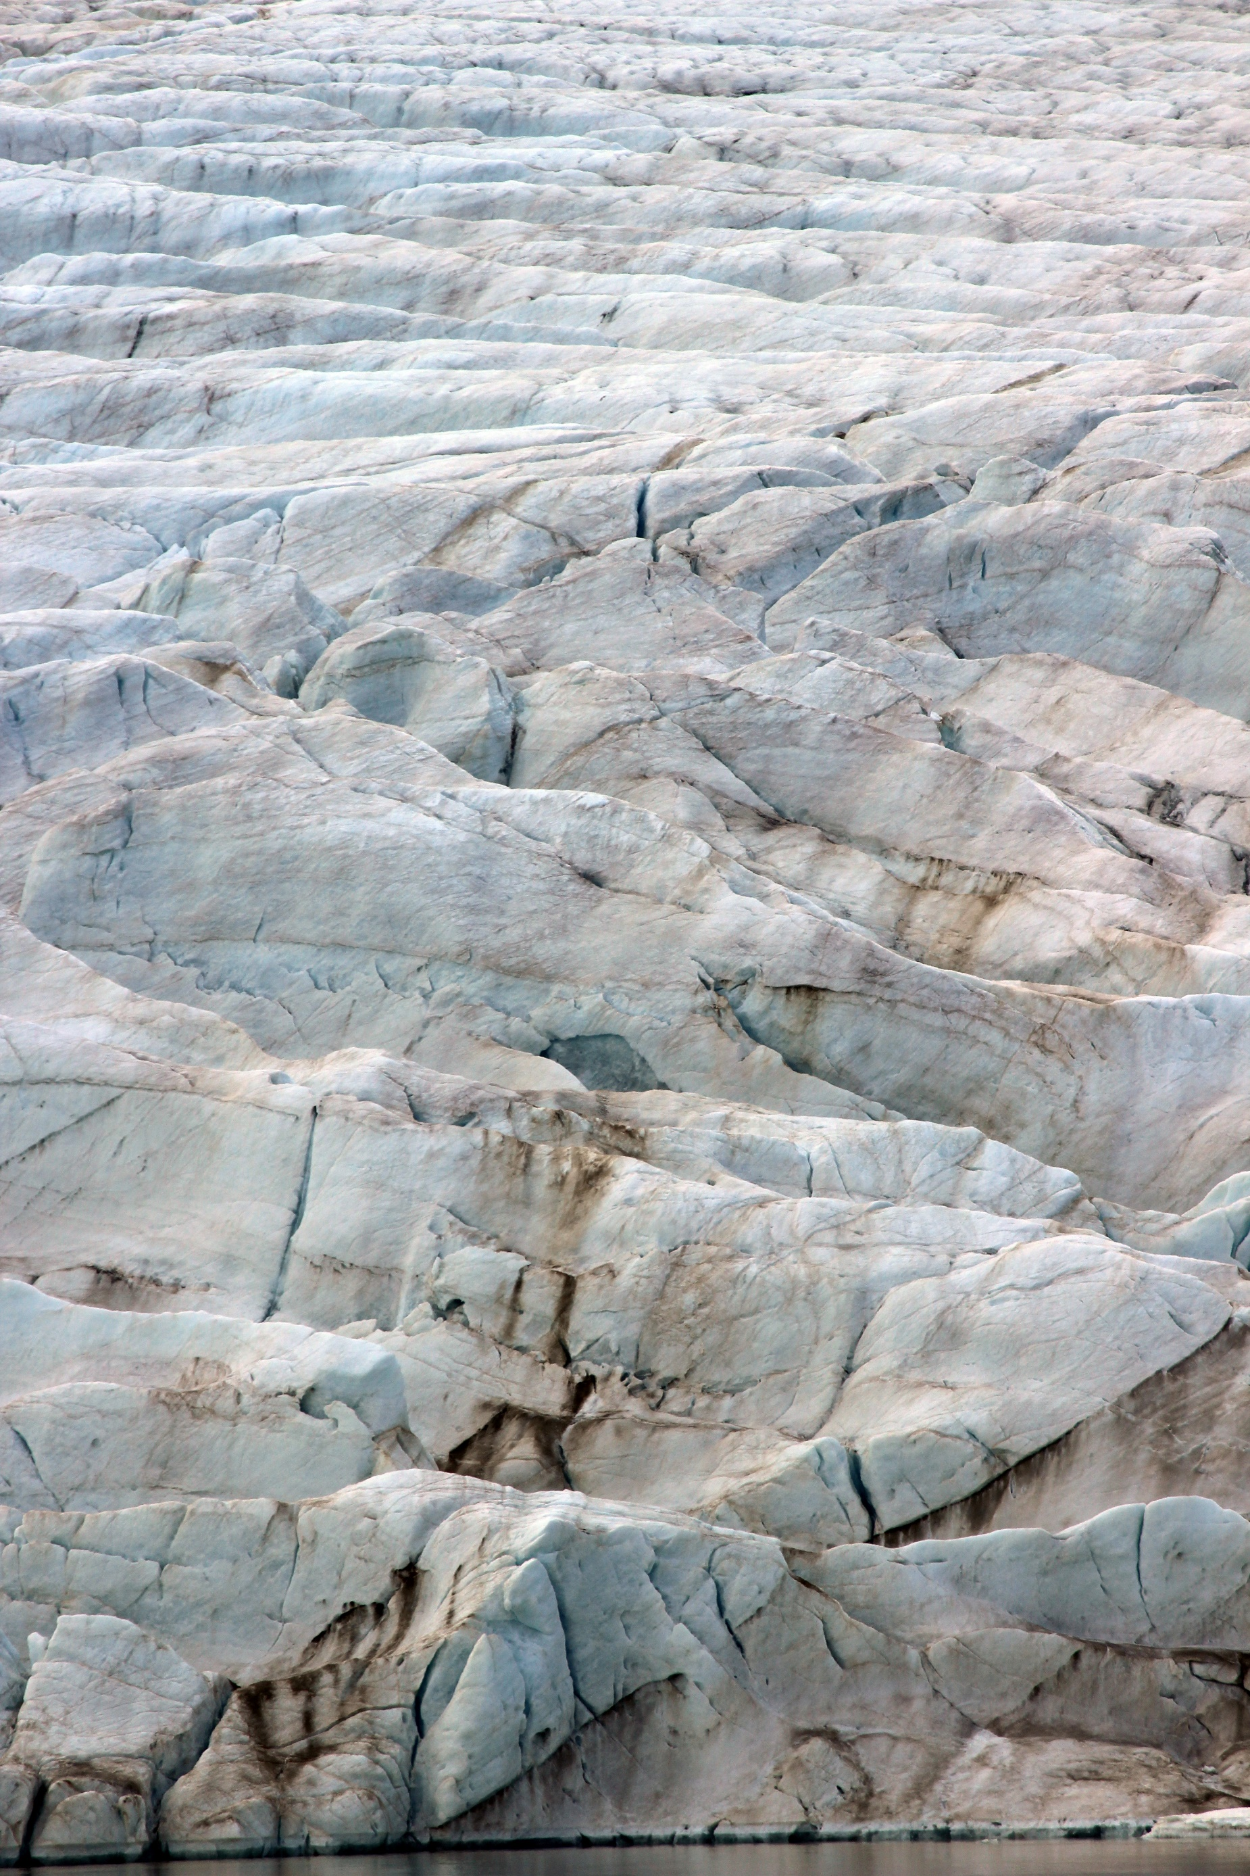

Advancing Collaboration in Canada-U.S. Arctic
Regional Security (ACCUSARS)
Invitational Workshop

17-18 September 2020
Workshop Information and Agenda

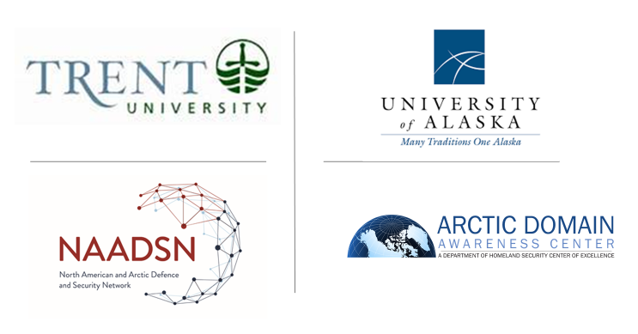

As/of 17 September 2020

Introduction

The Arctic region continues to evolve into an ever more complex domain. Significantly warming temperatures are inducing drastic changes to the physical environment. At the same time, human activity in the region is rapidly increasing. Such activities range from the helpful efforts of government entities, Indigenous groups, various industries, non-profit groups, academics and research; to the unhelpful measures of rising competition that correspondingly risks confrontation, as well as dramatic increases in criminal activities that often co-opt law enforcement. The collective result of these activities is driving rapid change across the “human terrain” of the Arctic, while in parallel to the rapid pace of the changing physical terrain.

Two Arctic research-focused teams…the Arctic Domain Awareness Center (ADAC), a U.S. Department of Homeland Security Center of Excellence in Maritime Research, hosted by the University of Alaska Anchorage, and the North American and Arctic Defence and Security Network (NAADSN), hosted by Trent University in Peterborough, Ontario, are seeking to advance baselines of analysis that will result in greater understanding of the developing security challenges and risks affecting the North American Arctic.

Building upon a June 2017 workshop on Security in the Arctic Borderlands Region, the North American Marine and Environmental Security Workshop in September 2018, and the Alaskan Command’s Arctic Symposium held in November 2019, NAADSN and ADAC are pleased to co-host a follow-on workshop to focus on specific initiatives that will improve understanding and enhance collaboration between Canada and U.S. Arctic security and defense professionals.

The Arctic region represents an important international crossroads where issues of climate change impacts on the environment, international trade, and global security meet. State and commercial actors from around the world seek to share in the long-term benefits of an accessible Arctic. However, some of this increased activity in the region has the potential to threaten U.S. and Canadian sovereign interests, including activities outside of the traditional military realm, such as increased growing foreign investment, tourism and scientific research.
By focusing on emerging trends in the medium- and long-term North American Arctic security environment, the gathering of academics and practitioners at this workshop will seek to anticipate potential North American Arctic futures in order to better identify and codify the understood capability gaps and shortfalls when it comes to securing Canada and U.S. sovereign territory in the Arctic. Workshop participants and panelists will also assess the challenges of achieving domestic security in a region that remains sparsely occupied by security forces and infrastructure.

Workshop Day 1 will explore the intersection of current context and coming challenges for the North American Arctic, including: the changing physical environment and climate; economic opportunities; surface and maritime transportation networks; infrastructure and communication needs; foreign economic and military interests impacting Canada and the U.S. High North; and symmetrical and asymmetrical threats to North American security. Workshop Day 2 will focus on contemplating the future security environment of the North American Arctic in order to frame gaps and shortfalls. The activities of Day 2 will further seek to generate research questions designed to provide useful knowledge products to support policy makers, as well as defense and security communities. In sum, these will include recommended strategic approaches, in addition to policy and resourcing decisions useful to reducing and/or mitigating risk. Supporting questions will focus on the pathways necessary to develop useful/practical solutions, oriented to the outcomes most helpful to achieving a peaceful and safe opening of the Arctic region.

The ACCUSARS two-day workshop will consist of panel presentations and breakout group activities that will use online technology while accomplishing Delphi style priorities.

Chatham House protocols will be in effect for the entire workshop. The workshop will also be recorded in order to gain accurate understanding of the discussions. However, this recording will not be released to the public.

Notes taken during the meeting will be formed into a summary report which will be shared with NAADSN and ADAC networks, including DND/CAF, DHS, and the broader community of CANUS Arctic security professionals.

Workshop Agenda

Thursday, 17 September 2020
0800-1230 Alaska Daylight Time (AKDT) / 1000-14300 Mountain Daylight Time (MDT) 1200-1630 Eastern Daylight Time (EDT)
Workshop Day 1
0800-0810 AKDT / 1000-1010 MDT/1200-1210 EDT:
Welcome and orienting remarks
Administrative remarks by Dr. Whitney Lackenbauer, Network Lead, North American Arctic Defence and Security Network, Trent University, and Maj Gen (Ret), Church Kee, USAF, Executive Director, Arctic Domain Awareness Center, University of Alaska
0810-0930 AKDT/1010-1130 MDT/1210-1330 EDT:
The Confluence of Canadian and U.S. Arctic Security Interests
How do Canadian and American Arctic strategic security frameworks compare to one another?
This panel will refresh workshop participants on the current focus of leaders of security and defense forces, Arctic Indigenous leaders concerned with North America’s “Northernmost Border” security, and academic thought leaders who contribute to understanding the challenges and concerns of the changing physical terrain and “human terrain” of the North American Arctic.
Panel Moderator: Church Kee
Opening remarks by Commander Alaska Command, Alaska NORAD Region and 11th Air Force, Lt Gen David Krumm, USAF, Joint Base Elmendorf-Richardson, Alaska (Confirmed).
Panelists:
- Canadian Armed Forces Northern Perspective: BGen Patrick Carpentier, RCAF, Commander, Joint Task Force North, Yellowknife Northwest Territories (NWT) (Confirmed).
- Alaska Command & U.S. Army Alaska Perspective: MG Peter Andrysiak, USA, Deputy CDR, ALCOM and CDR, USARAK, Joint Base Elmendorf-Richardson, Alaska (Confirmed).
- USCG District 17 (D17) Commander RADM Matt Bell, USCG (Alaska and U.S. Arctic). Juneau Alaska (Confirmed).
- Assistant Commissioner – Arctic Region: Neil O’Rourke, Canadian Coast Guard Ottawa Ontario (Confirmed).
- Indigenous reflections on the Arctic Security: Gail Schubert, President and CEO, Bering Straits Native Corporation, Nome, Alaska (Confirmed).
- Academic reflections: Dr. Rob Huebert, University of Calgary, Alberta (Confirmed).

0930-0940 AKDT/1130-1140 MDT/1330-1340 EDT

Break
0940-1040 AKDT/1140-1240 MDT/1340-1440 EDT
The Arctic Security Environment: Deepening, Broadening, and Sharpening our Strategic Analysis
Shifting power dynamics in the Arctic include increased militarization, Chinese activity, Russian actions and responses, and engagement with ‘partners’ considered adversaries in other venues. How do Canada and the U.S. conceptualize these dynamics as potential security risks or threats through, to, and in the North American Arctic?
This panel brings together an analytical perspective from strategists, planners and research experts.
Panel Moderator: Church Kee
Panelists:
- NAADSN: Dr. P. Whitney Lackenbauer, “Through / To / In: A Framework for Analysis” Trent University, Peterborough, Ontario (Confirmed).
- U.S. Naval War College: Dr. Rebecca Pincus, Naval War College, Newport Rhode Island (Confirmed).
- NORAD: Cmdre Jamie Clark. Royal Canadian Navy, Colorado Springs, Colorado (Confirmed).
- ALCOM: CAPT Layne McDowell, USN, Director, Strategies and Plans (J5), Joint Base Elmendorf-Richardson, Alaska (Confirmed).
- USNORTHCOM: Dan Torweihe, J5 Colorado Springs, Colorado (Confirmed).
- Ecole nationale d’administration publique : Dr. Stéphane Roussel professor of political science (Confirmed). Note : ’Ecole nationale d’administration publique is the national school for public administration in Montreal & Gatineau, Québec

1040-1050 AKDT/1240-1250 MDT/1440-1450 EDT
Introduction to Strategic Foresight Activity
- 10-minute briefing by Dr. Whitney Lackenbauer and Dr. Nancy Teeple (Fulbright, NAADSN) (Confirmed).
- Goal: to produce a report on the applicability of NATO SFA trends to North American Arctic defence and security futures, to support efforts to develop coordinated strategies to anticipate and respond to potential risks, as well as taking advantage of opportunities that arise from a rapidly changing, complex security environment.

1050-1100 AKDT/1250-1300 MDT/1450-1500 EDT
Break
1100-1200 AKDT/1300-1400 MDT/1500-1600 EDT
Strategic Foresight Activity: Converting Themes and Trends into Indicators of Threat/Risk
- Over the last eight months, the North American and Arctic Defence and Security Network (NAADSN) has applied the NATO Strategic Foresight Analysis (SFA) findings to Canadian Arctic defence and security policy and to help frame a conceptual model that anticipates and conveys an understanding of the future Arctic security environment.
  - In advance of the ACCUSARS workshop, participants will be provided with a short, draft narrative (akin to the NATO SFA theme chapters) describing relationships between NATO SFA trends, and Arctic defence and security implications across various scales (global, regional, national), and, ideally, identifying key indicators that might suggest changing risk or threat levels in the defence and security domains.
  - Do participants agree with the assumptions and projections? Do they apply to the North American Arctic as a whole?
  - Based on these observations and discussions, what are the primary indicators of changing risk or threat levels to the North American Arctic?

- In six (6) planned breakout groups, ACCUSARS participants will assess the North American Arctic defence/defense and security implications of one theme described in the 2017 NATO SFA (political, human, economics/resources, and environment) in detail.
- Each breakout group targeting one of the major themes identified by the 2017 NATO Strategic Framework Assessment (SFA) as particularly relevant to defence/defense and security implications in the North American Arctic. Brief descriptions of each theme will be provided by the workshop planners, as well as placemats for each respective theme, which provide a description of the risks, threats, and challenges associated with each theme as they relate to the most recent U.S. documents on Arctic strategy. These placemats provide complementary information to the SFA report, which details the Canadian perspective. The six breakout themes, including the assigned breakout group moderator as listed below.
  - Group 1: Political: International / Governance Challenges - Moderated by Dr. Rob Huebert, University of Calgary, Calgary Alberta. (Confirmed).
  - Group 2: Political: Regional / Circumpolar / North America - Moderated by Troy Bouffard, CASR, University of Alaska Fairbanks. (Confirmed).
  - Group 3: Political: National / North American Arctic - Moderated by Church Kee, ADAC, University of Alaska Anchorage. (Confirmed).
  - Group 4: Human Security - Moderated by Elizabeth "Ellee" Matthews, ADAC, University of Alaska Anchorage. (Confirmed).
  - Group 5: Environmental - Moderated by Dr. Paul Berkman, Tufts University, Medford Massachusetts. (Confirmed).
  - Group 6: Economic / Resources - Moderated by Dr. Whitney Lackenbauer, Trent University, Peterborough, Ontario. (Confirmed).
1200-1220 AKDT/1400-1420 MDT/1600-1620 EDT
Strategic Foresight Activity - reports and discussion
1220-1230 AKDT/1420-1430 MDT/1620-1630 EDT
Daily Wrap-Up and Agenda for Day 2 (Led by Whitney and Church)

Friday, 18 September 2020
0830-1230 AKDT / 1030-1430 MDT/1230-1630 EDT
Workshop Day 2
0830-0840 AKDT/1030-1040 MDT/1230-1240 EDT
Administrative remarks by Dr. Whitney Lackenbauer, Network Lead, North American Arctic Defence and Security Network, Trent University, and Church Kee, Executive Director, Arctic Domain Awareness Center, University of Alaska
0840-0950 AKDT/1040-1150 MDT/1240-1350 EDT
The Homeland is Not a Sanctuary: Capabilities and Strategic Messaging (roundtable)
- The Commander NORAD/USNORTHCOM, in recent testimonies to Congress, has described the North American homeland as no longer a sanctuary owing to evolving threats. How well known are these risks and threats to the Canadian and American populace, politicians, and by policy makers? What is the realistic scope of responsibility that CANUS Defense/Defence and Security focused teams can assume in the Arctic, particularly given resource constraints and competing global demands? What additional resources might be required to meet current and future expectations?
Panel Moderator: by Church Kee
  - University of Manitoba/NAADSN: Dr. Andrea Charron (Confirmed)
  - U.S. Department of Homeland Security reflections: Mr. Sean Moon, DHS Arctic Policy Department of Homeland Security, Washington D.C. (Confirmed).
  - U.S. Coast Guard reflections: Mr. Shannon Jenkins, USCG Senior Arctic Policy Advisor, Headquarters U.S. Coast Guard, Washington D.C. (Confirmed).
  - Canadian Coast Guard Fleet: Capt(N) (ret’d) Derek Moss, Senior Director Ottawa Ontario (Confirmed).
  - Canada Army: BGen Louis Lapointe, Deputy Commander, USARAK Joint Base Elmendorf-Richardson, Alaska (Confirmed).
  - USAF: NORAD J3 Brig Gen Pete “Coach” Fesler Colorado Springs, Colorado (Confirmed).
0950-1040 AKDT/1150-1240 MDT/1350-1440 EDT:
Operational Insights: Gaps, Seams, and Best Practices (roundtable)
- What are the roles of land, sea, air, and/or special operations forces, as well as other government departments/agencies, in demonstrating sovereignty, enforcing laws, and exercising deterrence against activities that undermine or threaten to undermine CANUS interests in the North American Arctic? What forms and level of surveillance are required? How do we operate in this environment to achieve these effects? How can CANUS practitioner’s better share “best practices”?
Panel Moderator: Troy Bouffard, Center for Arctic Security and Resilience, UAF, Fairbanks, Alaska.
  - US 2nd Fleet (TBC), RAdm Steve Waddell, RCN, Vice Commander, Norfolk Virginia (Confirmed).
  - International Cooperation Engagement Program for Polar Research (ICE-PPR), Mr. John Woods, Office of Naval Research, Washington D.C. (Confirmed)
  - Department of Defense Advisor, Dr. Lil Alessa, Presidential Professor, University of Idaho, Moscow Idaho (Confirmed).
  - Canadian Defence Research and Development, Adrienne Turnbull, Department of National Defence R&D Center, Ottawa, Ontario (Confirmed).
  - Arctic Domain Awareness Center Maj Gen (Ret), Church Kee, USAF, Executive Director, UAA, Anchorage, Alaska (Confirmed).

1040-1050 AKDT/1240-1250 MDT/1440-1450 EDT
Break
1050-1100 AKDT/1250-1300 MDT/1450-1300 EDT
Introduction to Setting North American Arctic Research Priorities Activity
- 10-minute briefing by Dr. Nettie Labelle-Hamer Interim Vice Chancellor for Research and Troy Bouffard Associate Director, Center of Arctic Security and Resilience, UAF, Fairbanks, Alaska (Confirmed).
1100-1200 AKDT/1300-1400 MDT/1300-1400 EDT
Setting North American Arctic Research Priorities: Threats Through and To the North American Arctic
- In four (4) breakout groups, ACCUSARS participants will identify key priorities for North American defence/defense and security collaboration. Given the changing nature of the threats through/to/in the North American Arctic, are we investing in the right capabilities? How can research & development help to identify and develop other capabilities that would support CANUS objectives in the Arctic? Breakout group monitors:
  - Group 1: Aerospace Domain: Dr. Nettie La Belle-Hamer, UAF, Fairbanks, Alaska (Confirmed)
  - Group 2: Maritime Domain: Church Kee/ ADAC, UAA, Anchorage, Alaska (Confirmed).
  - Group 3: Land Domain: Dr. Nancy Teeple, NAADSN, Trent University, Peterborough Ontario (Confirmed)
  - Group 4: Information Domain: Dr. Whitney Lackenbauer, Trent University, Peterborough, Ontario (Confirmed).
1200-1220 AKDT/1400-1420 MDT/1600-1620 EDT
Arctic Research Priorities Activity - reports and discussion
1220-1230 AKDT/1420-1430/1620-1630 EDT
Final workshop wrap-up remarks by Church Kee and Whitney Lackenbauer
Workshop venue - Online via Zoom.

Day 1 (17 Sep 2020)
Join Zoom Meeting
ID: 96674058524
Password: 818472
(US) +1 312-626-6799‬‬‬‬‬‬
96674058524@zoomcrc.com‬‬‬‬‬‬
Passcode: 818472

Day 2 (18 Sep 2020)
Join Zoom Meeting

ID: 98126975611
Password: 331986

(US) +1 929-205-6099‬‬‬‬‬‬

98126975611@zoomcrc.com‬‬‬‬‬‬

Passcode: 331986

Workshop method - Panel presentations followed by breakout group reflections, which is captured and promulgated via a comprehensive report.

Workshop objective - Workshop planners seek insights from workshop participants for their professional and informed perspectives in order to create a report of concerns, opportunities, recommendations and inquiries to address anticipated challenges to the medium and longer term North American Arctic security environment. Notes taken during the meeting will be formed into a summary report, allowing coordination across the community of planners. Once finalized, the report will be provided to the community of CANUS Arctic Security Professionals. The report will also be shared with the workshop planner’s respective Arctic Research Community of Interest. A tailored journal article and/or other deliverables may also be suitable follow-on considerations.

Subsequent Workshops:

- January 2021 – ACCUSARS2: Threats to the Approaches to North American Arctic

- May/June 2021 – ACCUSARS3: Threats Through/In the North American Arctic

